Week 10 - Continuing Cryptography

Modern Cryptography
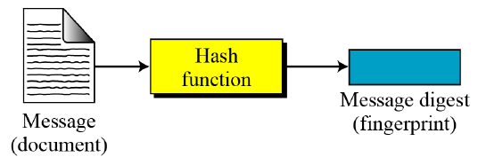
- Two-way cryptography
  - Symmetric cryptography
  - Public key cryptography
- One-way cryptography
  - Hash

Authentication Requirements
In the context of communication across a network, the following attacks can be identified:
- Disclosure – release of message contents to any person or process not having the key.
- Traffic analysis – discovery of the pattern of traffic between parties.
- Masquerade – insertion of messages into the network from fraudulent sources.
- Content modification – changes to the content of the message, including insertion, deletion, transposition and modification.
- Sequence modification – any modification to a sequence of messages between parties, including insertion, deletion and reordering.
- Timing modification – delay or replay of messages.
- Source repudiation – denial of transmission of message by source (sender of message denies they sent the message).
- Destination repudiation – denial of transmission of message by destination (recipient denies ever having received the message).
Measures to deal with first two attacks are in the realm of message confidentiality. Measures to deal with 3 through 6 are regarded as message authentication. Item 7 comes under digital signature and dealing with item 8 may require a combination of digital signature and a protocol to counter this attack.

Authentication Functions
- Any message authentication or digital signature mechanism can be viewed as having fundamentally two levels.
  - At the lower level, there may be some sort of function that produces an authenticator, a value to be used to authenticate a message.
  - This lower layer function is then used as primitive in a higher-layer authentication protocol that enables a receiver to verify the authenticity of a message.
- The different types of functions that may be used to produce an authenticator are as follows:
- Message encryption – the cipher text of the entire message serves as its authenticator.
- Hash function – a public function that maps a message of any length into a fixed length hash value, which serves as the authenticator
- Message authentication code (MAC) – a public function of the message and a secret key that produces a fixed length value serves as the authenticator.

Hash Function
- A hash algorithm creates a unique “digital fingerprint” (= message digest or digest)
- It’s a ONE-WAY function
  - Content cannot be used to reveal the original data
  - Takes a variable-length string as input
  - Returns a fixed-length string as output
- Even a small change in the input drastically changes the output
- Primarily for authentication purposes
- Checking integrity of a message (ensure you don’t get changed messages)

Types of Hash Functions
- Popular hash function MD5
  - Produces 128-bit ciphertext
  - E.g., b9b985cdc61c8db72289ce54f0937eb2 (32 hex)
  - Thoroughly broken
- Government standard SHA-1, SHA-2
  - SHA-1: 160-bit ciphertext
  - E.g., 4751031b69d5480dfb30023f72640dd45a3c5de (40 hex)
  - Theoretical weaknesses
- “NEW” cryptographic hash function SHA-3
  - Too new to fully evaluate
  - Maybe good enough

Encryption vs Hash

Checking integrity
- There are a variety of ways in which a hash code can be used to provide message authentication.
  - Message + hash code encrypted using symmetric encryption
  - Only hash code is encrypted, using symmetric encryption
  - There are more as well
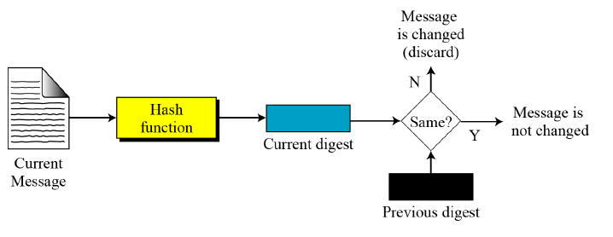

Hash Characteristics: Preimage Resistance
- Preimage attack = tries to find a message that has a specific hash value.
- Hash function should resist attacks on its preimage (set of possible inputs).
- Preimage resistance:
  - for essentially all pre-specified outputs, it is computationally infeasible to find any input that hashes to that output;
  - i.e., given $y=h(M)$, the output to message M, it is difficult to find another message, $M’$, that also equals the output to the hash function, $h(M')=y$.

Hash Characteristics: Collision Resistance
- Collision attack = tries to find an input that hash to the same output; i.e. find a message $M'$ not equal to original message, $M$, such that $h\left(M\right)=h(M^{'})$
- Collision resistance:
  - A hash function, $H$, is collision-resistant if it’s hard to find 2 inputs that hash to the same output
  - i.e., two inputs $a$ and $b$ where $a≠b$ but $H\left(a\right)=H(b)$
- Pigeonhole principle = any hash function with more inputs than outputs will necessarily have such collisions; the harder they are to find, the more secure

Hash: Summary
- Fixed Size: always produce same fixed size output no matter how long input is.
- Unique: 2 different sets of data cannot produce the same digest/code; known as a collision
- Original: should not be possible to produce a desired or predefined hash
- Secure: the resulting hash cannot be reversed in order to determine the original words
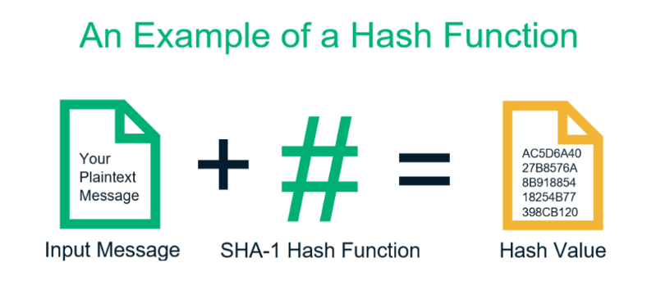

Message Authentication Code (MAC)
- An alternative authentication technique to hash functions.
- Primarily used to authenticate the sender of the message
- Involves use of secret key to generate small fixed-size block of data, known as checksum or MAC, that is appended to message.
- Assumes both communications share a common secret key

Digital Signatures
- cryptographic technique analogous to hand-written signatures
- Sender (Bob) digitally signs document, establishing he is document owner/creator.
- Verifiable, non-forgeable: recipient (Alice) can prove to someone that Bob, and no one else (including Alice), must have signed document
- Sender uses a signing algorithm to sign the message; message and signature are sent to receiver
- Receiver receives message and signature and applies the verifying algorithm to the combination; if the result is true, the message is accepted, otherwise not
- A digital signature needs a public-key system. The signer signs with her private key; the verifier verifies with the signer’s public key.

Signing the Digest
- Sender’s Side: A hash is created for the sender’s message. It is the hash that is signed by the private key of the sender (= digital signature). The original message and the digital signature is sent to the receiver.
- Receiver’s Side: Digital signature is verified by decrypting it with the sender’s public key which reveals the hash. A hash value of the message transmitted to the recipient is created and compared with the hash from the digital signature

Key Comparisons
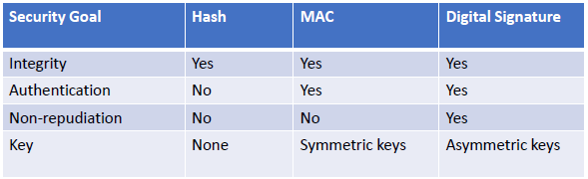
- Integrity – guarantee no unauthorized modification/deletion happened
- Authentication – proving who you are (did you send that message?)
- Non-repudiation – cannot deny knowledge of an action done by a user (I never sent that message to Julian)

Digital Certificate
- Problem: How to trust that a public key belong to whom it claims to be?
- Solution: Use trusted third-party entity. They vouch that a public key belongs to a particular individual or organization

Certification Authority
- CA issues the certification – signed with CA’s private key
- Each certificate has a period of validity. If there is no problem with the certificate, the CA issues a new certificate before the old one expires.

X.509 Certificate

Public Key Infrastructure
- Set of hardware, software, organizations, and policies to make Public Key Cryptography work on Internet
  - How to verify that the person sending the message
- User registers with a CA (e.g. VeriSign) and requests for an X.509 certificate
  - a Certificate Signing Request (CSR) is sent to CA
  - Must provide some proof of Identity
  - Levels of certification: simple email confirmation or background checks
- CA issues the digital certificate (signed by CA)
- User attaches the certificate to transactions (email, web, etc)
- Receiver authenticates transaction with CA’s public key
  - Contact CA to ensure the certificate is not revoked or expired

